**Predictive Analytics**

Predictive analytics is the use of data, statistical algorithms and [machine learning](https://www.sas.com/en_in/insights/analytics/machine-learning.html) techniques to identify the likelihood of future outcomes based on historical data. The goal is to go beyond knowing what has happened to providing a best assessment of what will happen in the future.

**Predictive Analytics History & Current Advances**

Though predictive analytics has been around for decades, it's a technology whose time has come. More and more organizations are turning to predictive analytics to increase their bottom line and competitive advantage. Why now?

* Growing volumes and types of data, and more interest in using data to produce valuable insights.
* Faster, cheaper computers.
* Easier-to-use software.
* Tougher economic conditions and a need for competitive differentiation.

With interactive and easy-to-use software becoming more prevalent, predictive analytics is no longer just the domain of mathematicians and statisticians. Business analysts and line-of-business experts are using these technologies as well.

**Why is predictive analytics important?**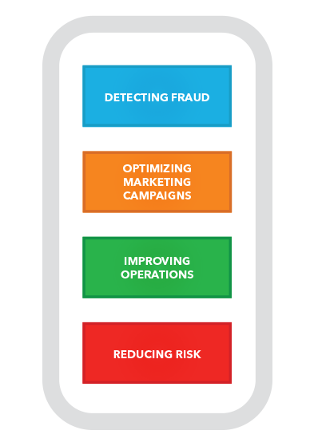

Organizations are turning to predictive analytics to help solve difficult problems and uncover new opportunities. Common uses include:

**Detecting fraud**

* Combining multiple analytics methods can improve pattern detection and prevent criminal behavior.
* As cybersecurity becomes a growing concern, high-performance behavioral analytics examines all actions on a network in real time to spot abnormalities that may indicate fraud, zero-day vulnerabilities and advanced persistent threats.

**Optimizing marketing campaigns.**

* Predictive analytics are used to determine customer responses or purchases, as well as promote cross-sell opportunities.
* Predictive models help businesses attract, retain and grow their most profitable customers.

**Improving operations.**

* Many companies use predictive models to forecast inventory and manage resources.
* Airlines use predictive analytics to set ticket prices.
* Hotels try to predict the number of guests for any given day to maximize occupancy and increase revenue. Predictive analytics enables organizations to function more efficiently.

**Reducing risk.**

* Credit scores are used to assess a buyer’s likelihood of default for purchases and are a well-known example of predictive analytics. A credit score is a number generated by a predictive model that incorporates all data relevant to a person’s creditworthiness.
* Other risk-related uses include insurance claims and collections.

### Who's using it?

### [Banking & Financial Services](https://www.sas.com/en_in/industry/banking.html)

* The financial industry, with huge amounts of data and money at stake, has long embraced predictive analytics to detect and reduce fraud, measure credit risk, maximize cross-sell/up-sell opportunities and retain valuable customers.
* Commonwealth Bank uses analytics to predict the likelihood of fraud activity for any given transaction before it is authorized – within 40 milliseconds of the transaction initiation.

### [Retail](https://www.sas.com/en_in/industry/retail.html)

* Since the now famous study that showed customers who buy milk often buy bread at the same time, retailers everywhere are using predictive analytics for [merchandise planning and price optimization](https://www.sas.com/en_in/industry/retail/solution/merchandise-planning-price-optimization.html),
* To analyze the effectiveness of promotional events and to determine which offers are most appropriate for consumers.

### [Oil, Gas & Utilities](https://www.sas.com/en_in/industry/oil-gas.html)

* Whether it is predicting equipment failures and future resource needs, mitigating safety and reliability risks, or improving overall performance, the energy industry has embraced predictive analytics with vigor.
* An analysis of machine sensor data predicts when power-generating turbines need maintenance.

### [Governments & the Public Sector](https://www.sas.com/en_in/industry/government.html)

* Governments have been key players in the advancement of computer technologies.
* The US Census Bureau has been analyzing data to understand population trends for decades.
* Governments now use predictive analytics like many other industries – to improve service and performance; detect and prevent fraud; and better understand consumer behavior.
* They also use predictive analytics to enhance cybersecurity.

## How It Works

Predictive models use known results to develop (or train) a model that can be used to predict values for different or new data. Modeling provides results in the form of predictions that represent a probability of the target variable (for example, revenue) based on estimated significance from a set of input variables.

**TRADITIONAL BUSINESS INTELLIGENCE (BI) VERSUS BIG DATA**

Following are the differences that one encounters dealing with traditional Bl and big data.

* In traditional BI environment, all the enterprise's data is housed in a central server whereas in a big data environment data resides in a distributed file system.
* The distributed file system scales by scaling in(decrease) or out(increase) horizontally as compared to typical database server that scales vertically.
* In traditional BI, data is generally analysed in an offline mode
* Whereas in big data, it is analysed in both real-time streaming as well as in offline mode.
* Traditional Bl is about structured data and it is here that data is taken to processing functions (move data to code)
* Whereas big data is about variety: Structured, semi- structured and unstructured data and here the processing functions are taken to the data (move code to data).

